Seeing Light Bend
You've probably observed a straw in a glass of water. Although straight, the straw appears bent. In this investigation, you will observe how three different liquids affect the speed of light and how things can be perceived by your eyes.
As you complete this investigation, keep in mind that each of these liquids exhibits a different index of refraction.

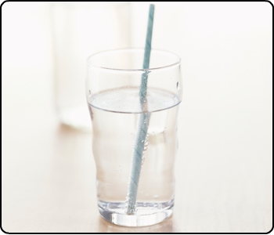

Seeing Light Bend
Have you ever tried to pick up an object from the bottom of a swimming pool? Before you got in the water, you probably looked at the object to figure out exactly where it was. Then once you got under the water, was the object where you thought it was? Investigate how water and other liquids affect the path of light

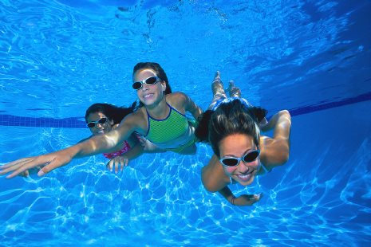

Example Problem

- Materials
Jeremy collected the materials he needed for the investigation:
- small saucepan
- clear drinking glass
- pencil
- penny
- liquid vegetable oil (150 mL)
- liquid dish soap (150 mL)
- paper towels
- water (150 mL)
- graduated cylinder

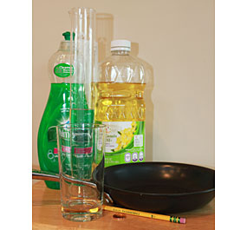
Image of all of the activity materials

- Straight Pencil
Next, he filled a drinking glass about two-thirds full of water and lowered the pencil into the glass, holding it as straight as possible. This is what Jeremy saw when he looked through the side of the glass.

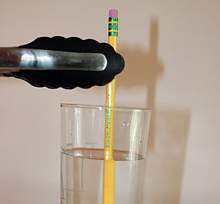
Image of pencil held by kitchen tongs halfway in a glass of water

- Angled Pencil
Jeremy then laid the pencil against the side of the glass so that it rested at an angle. This is what he saw when he looked through the side of the glass.

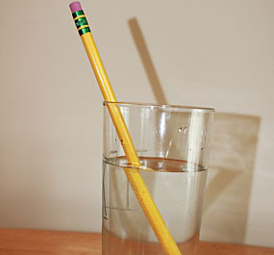
Image of pencil sitting at an angle on the top edge of the glass of water

- Penny: Trial 1
Jeremy placed a penny in the center of an empty saucepan. He looked down at the penny and then moved until he could no longer see the penny.

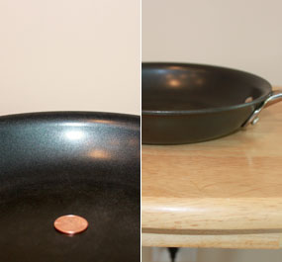
Image of penny in the center of a pan

- Penny in Water
Next, Jeremy gradually poured water into the saucepan without changing his position or the position of the penny. He stopped pouring the water as soon as he could see the edge of the penny.

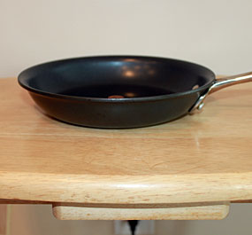
Image of penny in the center of a pan on a table

- Results: Water
This is how much water was left in the graduated cylinder when Jeremy could see the edge of the penny.

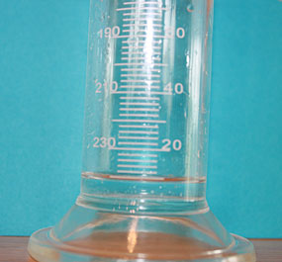
Image of graduated cylinder with small amount of water in the bottom
- Penny: Trial 2
Jeremy emptied the water out of the saucepan and the graduated cylinder. He dried these and the penny. He poured 150 mL of vegetable oil into his graduated cylinder. After placing the penny in the pan and finding the position at which he could no longer see the penny, Jeremy carefully poured the vegetable oil from the graduated cylinder into the pan.

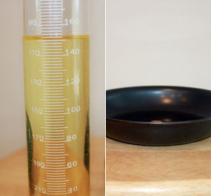
Image of graduated cylinder filled with 150 mL of vegetable oil next to the image of penny in the pan

- Penny in Oil
This is how much vegetable oil was left in the graduated cylinder when Jeremy could see the edge of the penny.

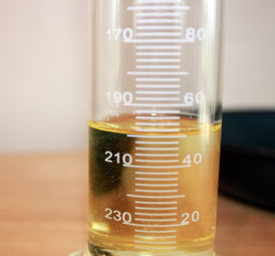
Image of graduated cylinder filled with vegetable oil

- Penny: Trial 3
Jeremy emptied the vegetable oil out of the saucepan and the graduated cylinder. He washed and dried these and the penny. He poured 150 mL of dish soap into his graduated cylinder. After placing the penny in the pan and finding the position at which he could no longer see the penny, Jeremy carefully poured the dish soap from the graduated cylinder into the pan.

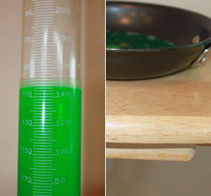
Image of graduated cylinder filled with 150 mL of dish soap next to the image of penny in the pan with dish soap

- Penny: Soap
This is how much dish soap was left in the graduated cylinder when Jeremy could see the edge of the penny.

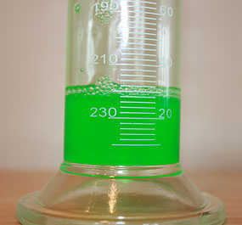
Image of graduated cylinder filled with dish soap

Assignment: Seeing Light Bend Investigation
Use your observations to answer the questions in this assignment.

